LAPORAN TUGAS ALGORITMA PEMOGRAMAN
TENTANG BAHASA NATURAL, FLOWCHART, PSUDOCODE, JAVA
TUGAS PEKAN 5
SISTEM PENGHITUNGAN BIAYA PENGIRIMAN PAKET



disusun Oleh:

UMAR ABDUL AZIZ
NIM 2511532012
KELAS IF B

DOSEN PENGAMPU :Dr.WAHYUDI S.T , M.T
ASISTEN LABORATORIUM: Muhammad Zaki Al Hafiz

DEPARTEMEN INFORMATIKA FAKULTAS TEKNOLOGI INFORMASI UNIVERSITAS ANDALAS
PADANG , 2025

FLOWCHART
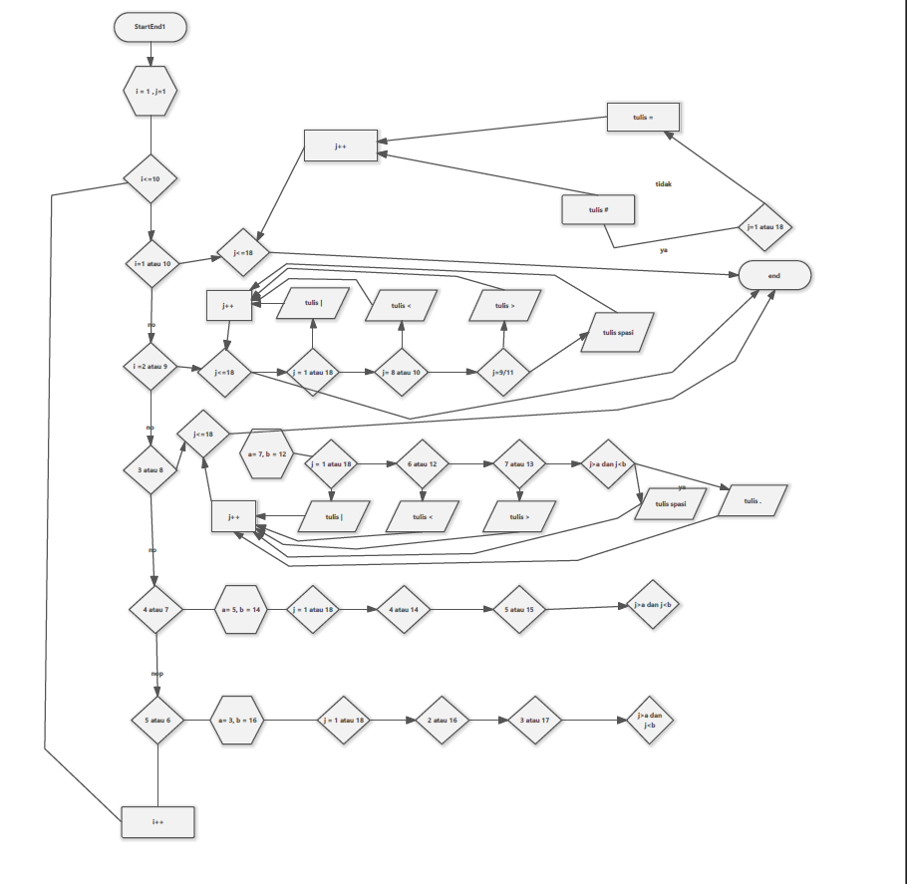

JAVA
package tugas_laprak;

public class tugasalppropekan5 {
public static void run(){
int a, b;//memori
for (int i = 1; i <= 10; i++) {
if(i==1 || i==10){
for (int j = 1; j <= 18; j++) {
if(j==1 || j==18){
System.out.print("#");
}
else{
System.out.print("=");
}
}
}
if(i==2 || i==9){
for (int j = 1; j <= 18; j++) {
if(j==1 ||j==18){
System.out.print("|");
}
else if(j==8 || j==10){
System.out.print("<");
}
else if(j==9 ||j==11){
System.out.print(">");
}else{
System.out.print(" ");
}
}
}
if(i==3 || i==8){
a=7;
b=12;
for (int j = 1; j <=18; j++) {
if(j==1 |j==18){
System.out.print("|");
}
else if(j==6 || j==12){
System.out.print("<");
}
else if(j==7 ||j==13){
System.out.print(">");
}else if(j>a && j<b){
System.out.print(".");
}else{
System.out.print(" ");
}
}
}
if(i==4 || i==7){
a=5;
b=14;
for (int j = 1; j <=18; j++) {
if(j==1 ||j==18){
System.out.print("|");
}
else if(j==4 || j==14){
System.out.print("<");
}
else if(j==5 ||j==15){
System.out.print(">");
}else if(j>a && j<b){
System.out.print(".");
}else{
System.out.print(" ");
}
}
}if(i==5 || i==6){
a=3;
b=16;
for (int j = 1; j <=18; j++) {
if(j==1 ||j==18){
System.out.print("|");
}
else if(j==2 || j==16){
System.out.print("<");
}
else if(j==3 ||j==17){
System.out.print(">");
}else if(j>a && j<b){
System.out.print(".");
}else{
System.out.print(" ");
}
}
}
System.out.println();
}
}
public static void main(String[] args) {
run();
}
}

